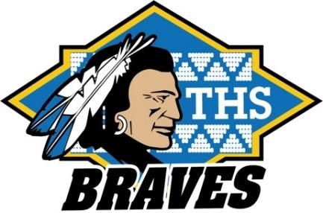
TWAIN HARTE SCHOOL

NEWSLETTER

www.twainharteschool.com

www.facebook.com/twainharteschool

Parent Newsletter for the week of April 10

MARK YOUR CALENDAR:
April 8 Cheer Leading tryouts at Summerville High, 9:00 a.m. – 2:00 p.m.
April 11 Spring Pictures – Watch for your picture envelopes!
April 12 Board of Trustees meeting, 4:00 p.m., Board Rm
April 18 4/5 Honor Roll Bowling Trip
April 19 Minimum Day dismissal
Kindergarten Registration, call for an appointment!
April 28 K-4 VIP Assembly, 9:00 a.m.
4-8 Character Counts Assembly, 2:10 p.m.

Kindergarten Registration for the 2017-18 school year will be Wednesday, April 19. Students must be 5 years old on or before September 1, 2017 to register for Kindergarten. If your student turns 5 between September 2, 2017 and December 2, 2017, they are eligible for Transitional Kindergarten. Copies of birth certificates, immunizations, and proof of residency are required to register. Please stop by the school office to pick up the Kindergarten Registration packet and to make your appointment for our registration.

PATHS would like to inform parents of students who participated in the Jelly Belly fundraiser that orders have been submitted. When we are notified of the delivery date, you will be contacted to schedule a date and time for pick up or delivery. We sincerely apologize for any inconvenience and thank you in advance for your patience. Please feel free to call either Edith (209)352-1667 or Vicki (209)770-2152 with any questions regarding this matter.

Time to get ready! On April 28th, the 8th grade class is hosting a Gym Lock-In. This event is open to our 4th-8th graders, and includes dinner, movie and many creative fun games. The 6th, 7th and 8th graders have the option of staying all night! This is guaranteed to be a safe, fun filled night your child will remember. Permission slips can be picked up from your student’s teacher or in the office. Please be sure they are turned in by April 21st so we can plan accordingly.

Summer Art Camp – The Tuolumne County Arts Alliance is hosting a Summer ARTS Camp for students ages 7 -12, June 19 – June 23 in Columbia State Historic Park. Summer ARTS camp meets Monday through Friday. Campers arrive at 8:45 a.m. and pickup is 12:00 noon, Monday through Thursday. Friday is Summer ARTS Camp performance, picnic, and Art Show hosted by the Columbia merchants. Advance registration is required. Registration forms are available in the school office.

Go Braves!

