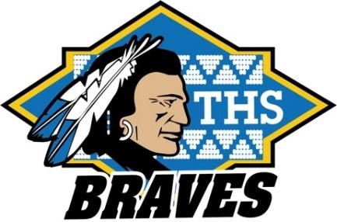
TWAIN HARTE SCHOOL

NEWSLETTER

www.twainharteschool.com

www.facebook.com/twainharteschool

Parent Newsletter for the week of October 16

MARK YOUR CALENDAR: School starts at 8:15 a.m.!
October 17 School picture make-ups and retakes
October 18 Minimum day dismissal
October 25 Minimum day dismissal
4-8 Braves Assembly, 1:15 p.m.
8th grade Parents’ meeting, cafeteria stage
October 26 K-3 V.I.P. Assembly, 9:30 a.m., cafeteria
October 31 Minimum day dismissal
Halloween Parade, 12:00 noon

All K-3 VIP Assemblies will now be held on the last Thursday of each month. The assemblies will start at 9:30 a.m. in the cafeteria.

Our Annual Halloween Parade is scheduled for Tuesday, October 31. We will have all students in costume parade through downtown Twain Harte leaving the school playground at 12:00 noon. Please remember to have your child’s costume appropriate for school. No simulated weapons please!

Picture Make-up and Re-takes - Tuesday, October 17 is student picture re-take and make-up day. Students wishing to have their picture retaken must return the original picture packet on re-take day. If your child was absent on picture day, you can have their picture taken on October 17. Picture order packets are available in the school office. You may also order pictures online at mylifetouch.com using the picture day ID EK067021Q1.

Safety first! Please be reminded that there is NO supervision on the school grounds until 8:00 a.m. Students dropped off at school earlier than 8:00 a.m. must report directly to the cafeteria until playground supervision is provided.

Spirit Wear Store – The Twain Harte School On-Line Spirit Wear Store is now open and will be open for a few weeks. All orders will ship after the store closes.
Place your orders today at http://www.myfanstand.com/Showroom/TwainHarte/503780.

Lost and Found - Cooler weather is upon us and our lost and found is already growing! Please remind your students to check both of our lost and founds for lost sweatshirts, jackets, and lunch boxes. The lost and found in the lower building is located in the main hallway outside the office, and in the mall area in the upper building. Also, please remember to put your child’s name on their things so we can help them find their way back together!

Go Braves!

